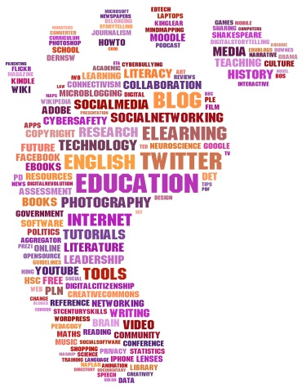
Creating a Positive Digital Footprint: Weebly Webpage
To help us go forward with our digital learning initiative, you will create a website of your own design to use as a platform to store creations, post your thoughts and communicate with our digital learning partner class. You will be given multiple opportunities to demonstrate some of the goals for our digital learning project:

- Identify factors/elements that influence and affect a digital footprint.
- Build a digital footprint by constructing a personal website for a specific purpose and audience.
- Recognize the impact a digital footprint has, and reflect on the impact of your own digital footprint.

Step 1: If creating a Weebly is new to you, watch this helpful instructional video before getting started: http://bit.ly/1qkdsgs.
Step 2: Create a Weebly webpage (www.weebly.com). Choose a theme, colours, fonts and other aesthetic features that appeal to you (you can always change these later). Give your website a name. Not just your name, but a name that captures your personality, is appropriate and will encompass your work.

Step 3: Include the following mandatory pages on your website: Home, Blog, Twelfth Night, Mythology, Literature Circles, ISU. You may want to add other pages (e.g. Writing Ideas, Reading Recommendations, etc.), and you can feel free to do so either now or later.

Step 4: Create a biography on your home page. In approximately two hundred (200) words, it should explain who you are. You may want to write about hobbies, family, vacations, your extracurricular activities or anything that defines you. Also, include a picture of something that represents you. Keep in mind that this website is a reflection of who you are. Your image is reflected through the words, images, links, video, etc. that you post on the site. Be thoughtful, intentional and creative.

Step 5: Once you’re ready to “Publish,” save the url of your website and submit it to the following Google Form: http://bit.ly/1u6kq9N.

DUE DATE: All websites need to be published by the end of March Break.

