~ Mr. Richardson’s Classes ~
Accessing Electronic Resources

Following are explanations as to how you can connect with the websites Mr. Richardson uses to post material and resources as well as to communicate with students and parents.
Weebly

Visit the “Richardson’s Resources” website at http://richardsonsresources.weebly.com to check homework and assignment due dates as well as access course material and resources.

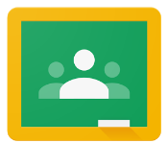
Google Classroom

All assignments (unless otherwise stated) are to be submitted via Google Classroom. Please login to your Googleapps account and visit https://classroom.google.com to see announcements and turn in assignments.

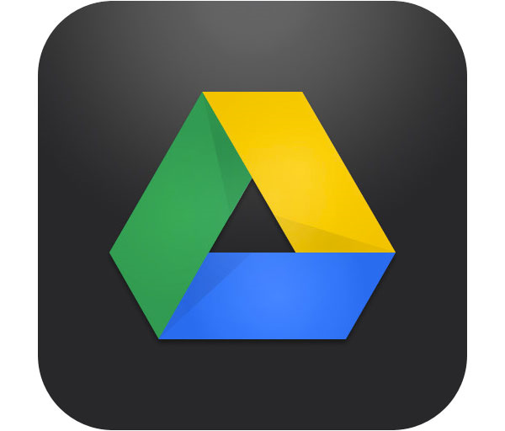
Google Drive

Visit the website http://google.wrdsb.ca, and login using your school username and password. This gives you access to your Google Drive files and folders. Please use Google Docs from your student account to complete all written assignments produced electronically, as it will give you the option of sharing your work for peer editing and teacher evaluation.

