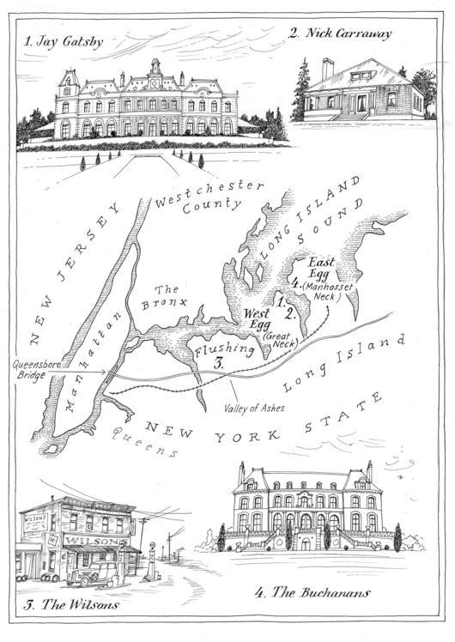

New York/Manhattan | valley of ashes | West Egg | East Egg

Who lives where in The Great Gatsby? What do the geographical settings represent?

