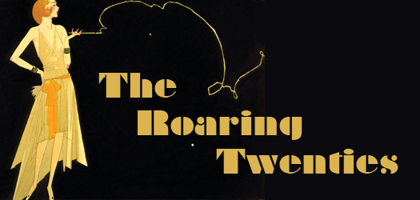

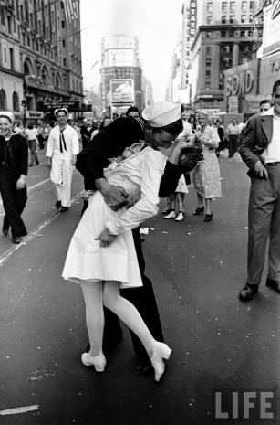

The First World War came to a conclusion in 1918, the United States having entered the conflict in 1917.

The Treaty of Versailles was signed in 1919, placing the majority of the blame for the War on Germany.

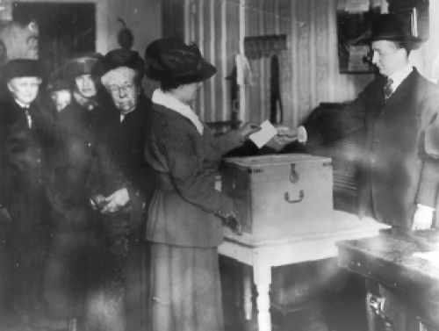

On August 26th, 1920, American women won the right to vote, when the 19th Amendment to the Constitution, the Woman Suffrage Amendment, was passed.

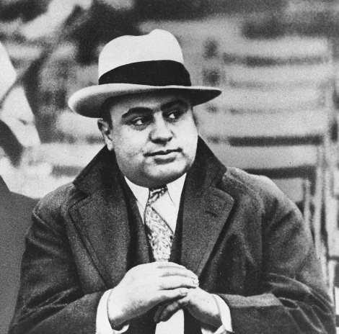

Prohibition laws were in place through the 1920s, with gangsters like Al Capone making a business of smuggling alcohol into the country.

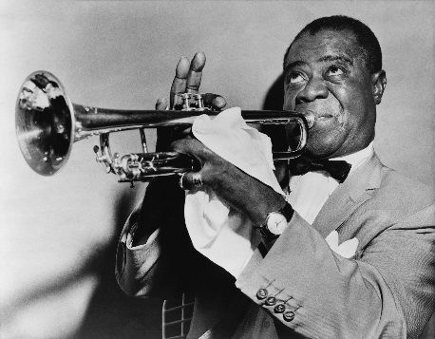
Jazz was a popular form of music at the time, with musicians like Duke Ellington and Louis Armstrong being very popular.

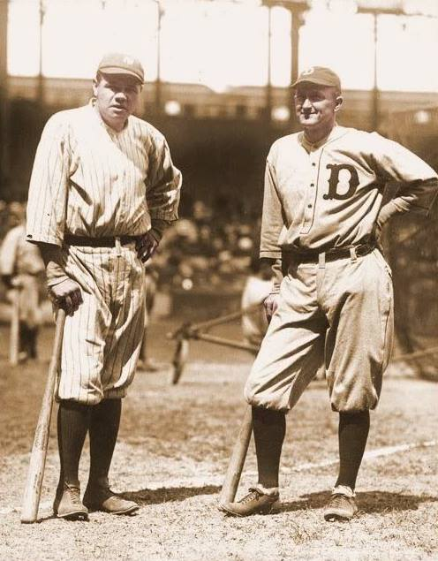

Babe Ruth and Ty Cobb were the kings of Major League Baseball.

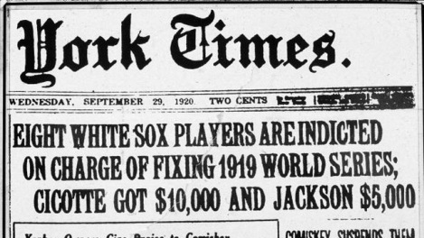
Eight members of the Chicago White Sox were banned from professional baseball for throwing the 1919 World Series. This became known as the “Black Sox Scandal.”

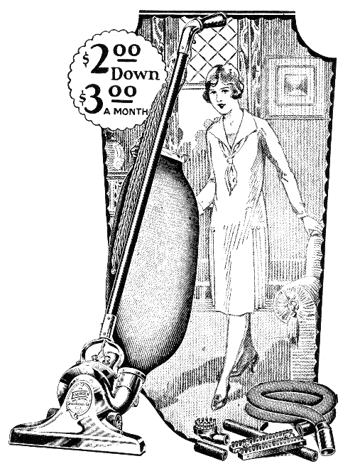
On August 3rd, 1923, Calvin Coolidge became President of the United States. Coolidge focused on promoting business during his time as President.

Many new products were invented and sold to Americans. These new products meant more jobs and, therefore, more money.

Vacuum cleaners, washing machines, cars, radios, etc. were very popular.

Many people began buying on credit and fell far into debt.

The Stock Market was very popular in the 1920s, with people being allowed to buy stocks on credit.

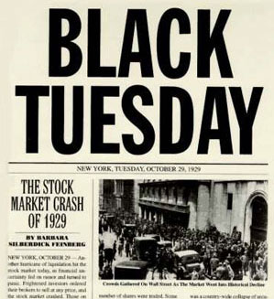

On October 29th, 1929 (a.k.a. “Black Tuesday”), the Stock Market Crash sent the United States into the Great Depression which would continue through much of the 1930s.

