
~ ENG 1PI ~
Newspaper Vocabulary

MASTHEAD – Information about the newspaper, such as the name of the publishing company, names of the offices of the company, location of editorial offices, editorship and distribution facts, all usually found at the top of the editorial page.

❶ NAMEPLATE (a.k.a. BANNER) – The name of the newspaper as it appears at the top of the front page. It is set in a particular style of type to be distinctive and easily recognized.

❷ HEADLINE – An explanatory title over a newspaper article summarizing the main point for the reader.

❸ BYLINE – The name of the article’s writer (usually printed at the very top of the story).

❹ LEAD – The first few sentences or the first paragraph of a news story, containing a summary of events or the introduction to the story.

❺ CAPTION – A line of text located below a photograph in the newspaper to explain what is depicted in the picture above.

❻ CREDIT LINE – A line giving the source of a picture (located along the photo’s border).

❼ JUMPLINE – A line at the end of an incomplete article on the cover page indicating the page within the newspaper on which the story continues (e.g. SEE HERO STUDENT: PAGE A3).

❽ 5WH – WHO, WHAT, WHEN, WHERE, WHY, HOW; the major questions answered in the lead of a well-written news story.

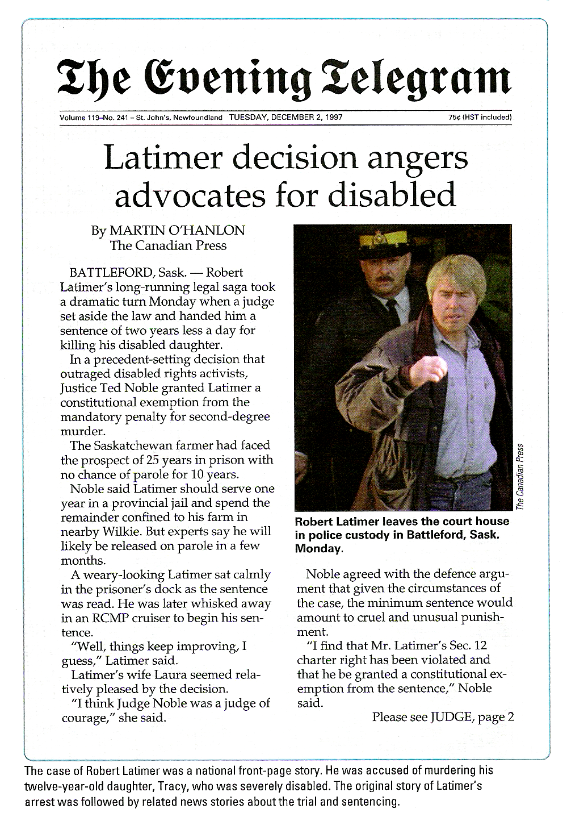

❶

❷

❸

❹

❽

❻

❺

❼

