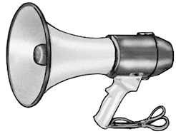
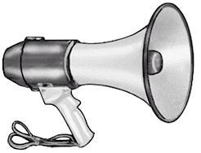
~ Independent Director Study ~
List of Directors

Each of the directors listed below is a suitable selection for this project (but feel free to suggest one of your own choosing, as well):

J.J. Abrams | David Fincher | Sarah Polley
Woody Allen | John Ford | Sam Raimi
Paul Thomas Anderson | Mel Gibson | Brett Ratner
Paul W.S. Anderson | Terry Gilliam | Rob Reiner
Wes Anderson | Christopher Guest | Ivan Reitman
Michael Bay | Paul Haggis | Jason Reitman
Kathryn Bigelow | Catherine Hardwicke | Robert Rodriguez
Danny Boyle | Jim Henson | George A. Romero
Kenneth Branagh | Alfred Hitchcock | Martin Scorcese
Mel Brooks | Tobe Hooper | Ridley Scott
Tim Burton | Ron Howard | Tony Scott
James Cameron | John Hughes | M. Night Shyamalan
Frank Capra | Peter Jackson | Bryan Singer
John Carpenter | Norman Jewison | Kevin Smith
Charlie Chaplin | Chuck Jones | Zack Snyder
Cohen Brothers | Stanley Kubrick | Steven Soderbergh
Chris Columbus | Akira Kurosawa | Steven Spielberg
Francis Ford Coppola | John Lasseter | Oliver Stone
Sofia Coppola | Spike Lee | Quentin Tarantino
Wes Craven | Sergio Leone | Gore Verbinski
David Cronenberg | George Lucas | Paul Verhoeven
Cameron Crowe | Baz Luhrmann | Wachowski Brothers
Frank Darabont | David Lynch | Orson Welles
Brian De Palma | Michael Mann | Joss Whedon
Guillermo Del Toro | Garry Marshall | Robert Wise
Richard Donner | Penny Marshall | John Woo
Clint Eastwood | Michael Moore | Ed Wood
Atom Egoyan | Christopher Nolan | Edgar Wright
Roland Emmerich | Frank Oz | David Yates
Farrelly Brothers | Wolfgang Petersen | Robert Zemeckis
John Favreau | Roman Polanski | Rob Zombie

